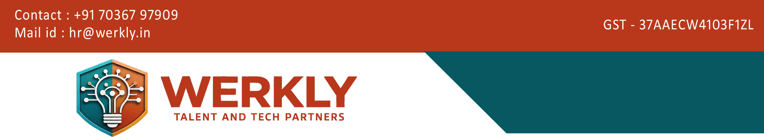

This Agreement is made on 17-05-2026 BETWEEN Werkly Consulting Private Limited havingIn its registered office at Hyderabad and Vijayawada and Converge Biotech Limited having its registered office at Sanath Nagar,

Scope of Services
Werkly Consulting Private Limited agrees to provide recruitment services to Converge Biotech Private Limited various roles as mutually agreed.

Fee Structure
Professional Charges for Permanent Employment Commercials
  - Junior Management (Executive to Asst. Manager): 7%
  - Middle Management (Deputy Manager to DGM): 7%
  - Senior Management (GM / AVP / VP & Above): 7%
  - CXO Positions: 7%

- Payment should be made within [90 days] from the date of candidate joining.

Candidate Ownership
  - A candidate submitted by either party will remain valid for 6 months.
  - Ownership belongs to the party who first introduced the candidate.

Replacement Policy
  - In case the candidate leaves within [90 days], a free replacement will be provided.
  - No refund shall be applicable.

Payment Terms

  - Payment must be made within the agreed timeline.

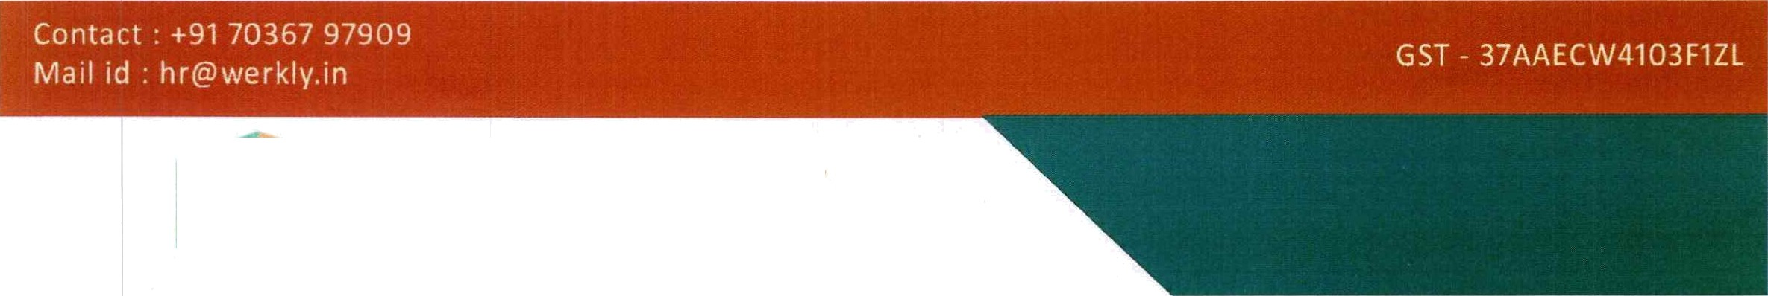
WERKLY
TA L E N T A N D T E C H PA R T N E R S
- Confidentiality
Both parties agree to maintain confidentiality of all shared information, including candidate
data and business details.

- Non-Solicitation
Both parties agree not to hire or approach each other's employees or clients during the agreement period and up to 1 year after termination.

- Jurisdiction
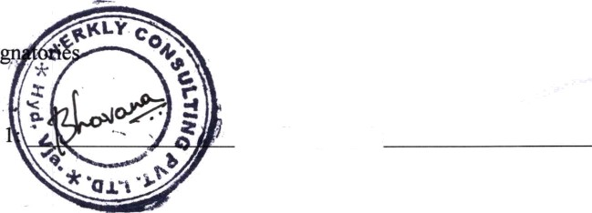
This Agreement shall be governed by the laws of India, and disputes shall be subject to the jurisdiction of courts in Hyderabad.

For Company 2:

Authorized Si

For Company

Date: J 7- o 9 -I Off',


Head0ñce-301,Sasfii Sadan,GothamiEndave,BotaWcalGadrden Road,KondapuçHyd-084 Brasch0tce- 2-1S5,PeerlaPanaCente,VeerapaneniGudem,Gannavram(MD)-286

